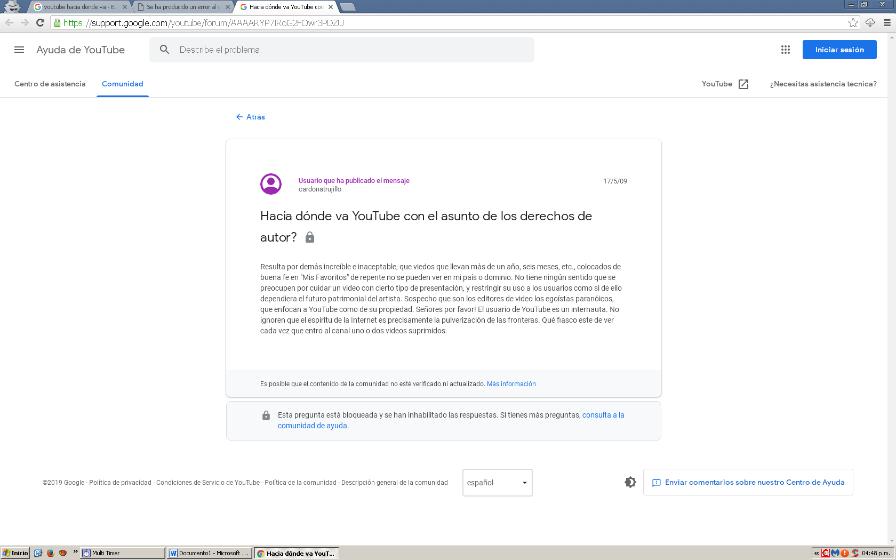

**YouTube’s clickbait problem reaches new heights**

YouTube is suffering from a clickbait epidemic — and has been for years. A recent video, however, caught the attention of almost every major creator and the community-at-large, reigniting conversation about the growing problem.

The video was by content creator Carmie Sellitto, who [goes by touchdalight on YouTube.](https://www.youtube.com/user/touchdalight)Entitled “One Kill = One Clothing With My 13-Year-Old Sister,” the video shows Sellitto’s friend and fellow YouTuber, Millie T, removing an article of clothing if he gets a kill in the game. She’s in no way related to him, and she’s certainly not 13.

Sellitto has since removed the video.

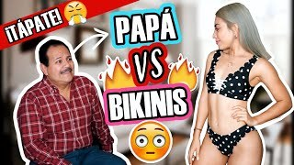

**COPYRIGHT**



**YOUTUBE KIDS**

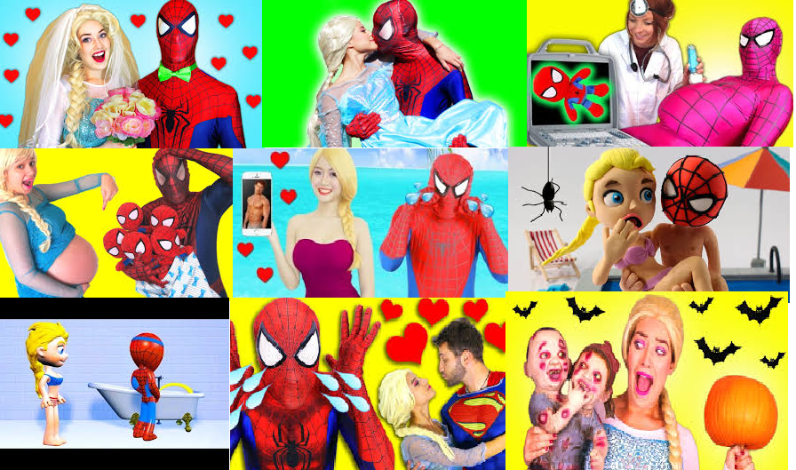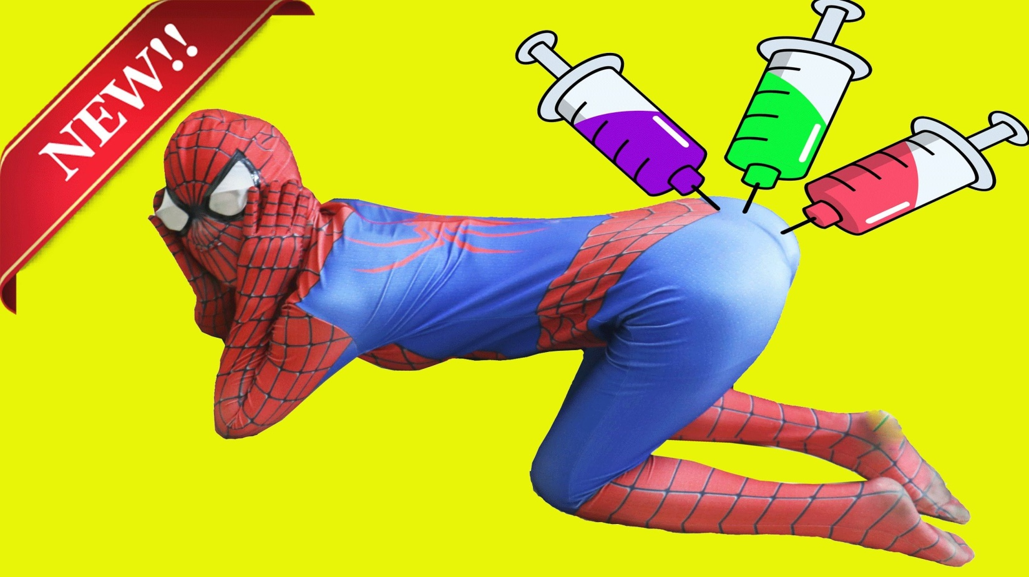

**YOUTUBE "TRENDINGS"**

**USA**

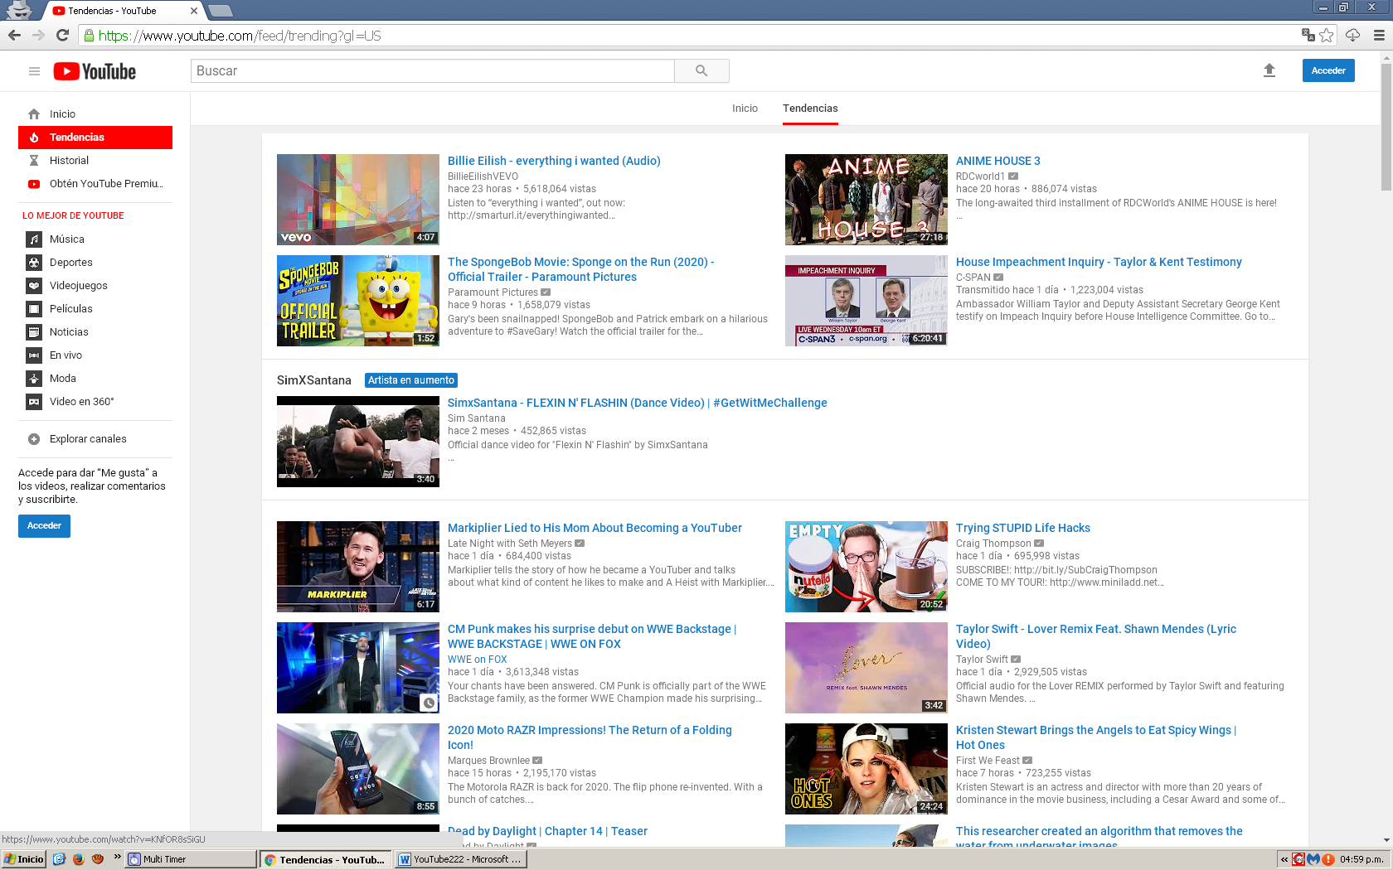

**SOUTH KOREA**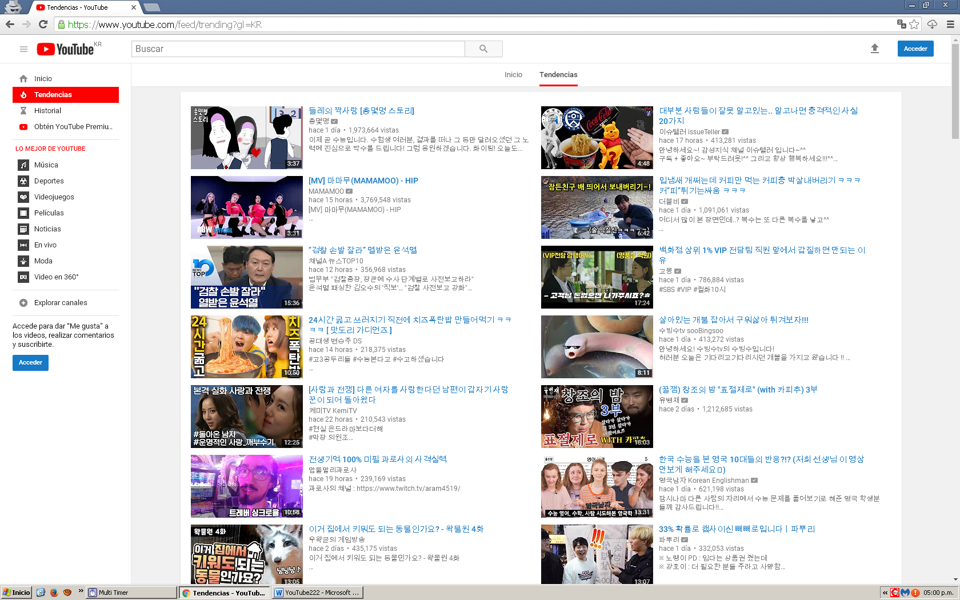

**GRECE**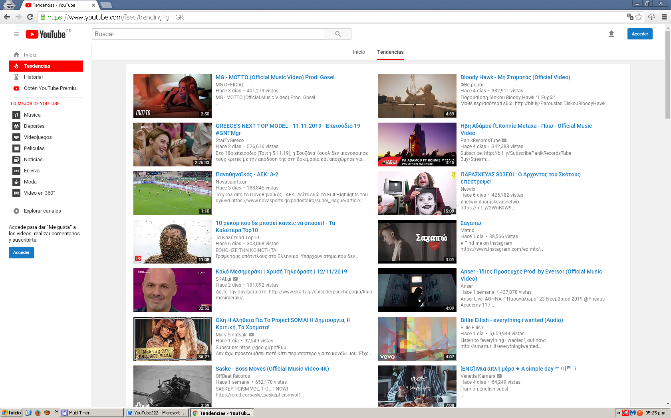

**URUGUAY**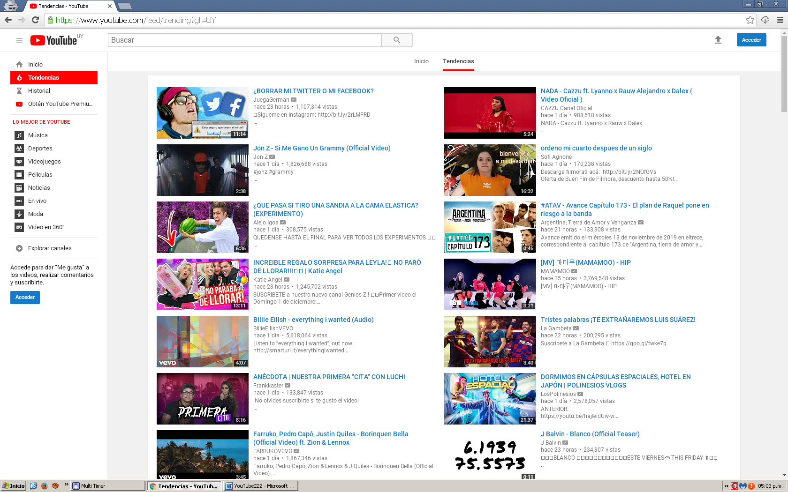

**WHAT IS THE FUTURE OF YOUTUBE?**

YouTube has become in a trash content web and will become in a few years in a TV-like platform. The content of good quality is disappearing. It results more and more difficult to find good content. We still remember when YouTube started people made content just for fun and never to make money but now that has changed. The companies are taking control over YouTube and forcing the creators to be more family friendly, but not family friendly in excess because for them that is bad too. YouTube wants you in a very thin line that it does not even realizes were it is.

There is also the topic of the copyright. Where you can upload your video very happy about it, but if it has a little tiny piece of a song, they delete the video and they will not pay any money to the creators. Everyone is noticing this and we started to see more and more creators complaining about the copyright policy of YouTube.

The TRENDINS OF YOUTUBE and YOUTUBE KIDS. It seems like YouTube is trying to force to the audience to see the most ridiculous content. And now we realize that this content YouTube is trying to force is the one that makes more money for it, obviously. On the other side is “YouTube kids”. You can download it but in less of five minutes you are going to realize why this is a bad platform for kids. Your screen will be plagued by strange and ridiculous videos of Spiderman that anybody knows who made them and the topics of those videos does not seem very family friendly.

YOUTUBE BECAME FROM A COMPANY WERE YOU COULD EXPRESS TO A COMPANY THAT ONLY CARES FOR MONEY

AND ITS FUTURE DOES NOT SEEMS GOOD

**THANK YOU FOR YOUR ATTENTION!!!!!1!!!**